Report: Lake ONtario Nearshore Zooplankton

  - Lake and Year: Lake Ontario 2023
  - Lead Organization: Cornell University
  - Authors of This Report:
James Watkins, Cornell University
Lars Rudstam, Cornell University
Anne Scofield, US Environmental Protection Agency, Great Lakes National Program Office
  - Contact(s) for Questions About this Report:
James Watkins, jmw237@cornell.edu

Project Overview

Zooplankton are an important intermediate step between primary producers and fish in both nearshore and offshore habitats. Zooplankton support forage fish in Lake Ontario including alewife and reintroduced coregonids. The zooplankton community has shifted dramatically over time, and several invasive zooplankton species have been introduced that impact food webs (Rudstam et al. 2015, Barbiero et al. 2019, Figary et al. 2023, Holeck et al. 2025). Calanoid copepods are becoming more prominent in both nearshore and offshore habitats, with notable declines in cyclopoid copepods and bosminids (Figary et al. 2023). Lake Ontario zooplankton work by Cornell University has been funded by the United States Environmental Protection Agency Great Lakes Program Office (US EPA GLNPO) through the Great Lakes Restoration Initiative (GLRI) which includes annual Long Term Biological Monitoring (LTM) and intensive sampling during the Cooperative Science and Monitoring Initiative (CSMI) years. The New York State Department of Environmental Conservation (NYS DEC) support the Cornell group’s efforts in the Lake Ontario Biomonitoring Program (BMP) that includes seasonal nearshore and offshore collections. Canada Department of Fisheries and Oceans (DFO) and Ontario Ministry of Natural Resources (OMNR) also monitor Lake Ontario zooplankton including along the north shore (Bowen et al. 2022).
The projects were organized around the following Lake Ontario 2023 science priority and research question:
  - Understand changing species dynamics, food web structure and energy transfer in Lake Ontario, including benthos, zooplankton, and fish populations.
Additional research questions explored as a result of this work include:
  - Comparing zooplankton abundance and community structure in nearshore and offshore habitats, including comparisons of the northern and southern shore and from west to east.
  - Detect new invasive species of zooplankton and assess status of previously introduced invasive species.
Study Highlights
- Zooplankton biomass within the upper 20 m of eight offshore sites was compared directly with zooplankton biomass collected at several nearshore sites ranging in depth from 10 to 50 m. Offshore sites (LTM, n=8, avg 47.6 mg dry wt per m³) had higher zooplankton biomass than nearshore sites on the north shore (CSMI North, n=6, 23.4 mg per m³), south shore (CSMI South, n=7, 17.0 mg per m³) and BMP south shore (n=10, 11.7 mg per m³) in August 2023, although there were no significant differences between the four groups.
- Zooplankton biomass was lowest at nearshore sites where the Niagara River enters Lake Ontario, suggesting a dilution effect of river flow.
- Copepod composition shifted from west to east for both offshore and nearshore sites, with cyclopoid copepods prominent in the west and calanoid copepods in the east. Daphnia and other cladocerans were generally more abundant in the west.
- No new exotic zooplankton species were detected. For exotic predatory cladocerans, Cercopagis pengoi was more abundant in western Lake Ontario while Bythotrephes longimanus was more abundant in the east, reaching particularly high biomass levels (10-20% of total) for LTM stations ON55M and ON63. Native predatory cladocerans were also collected, with Polyphemus pediculus particularly abundant at site ON 67b on the south shore near Olcott, NY.
- Dreissenid veligers were more abundant at nearshore (avg 21.7% of overall biomass) relative to offshore (6.6%) sites, and at some sites made up a primary component of zooplankton biomass (e.g. 66% at ON 67b on the south shore near Olcott, NY).
- Rotifers were a large (20%) component of nearshore and offshore zooplankton biomass.

Project: Lake Ontario Nearshore Zooplankton

Overview
Long-term monitoring of zooplankton by EPA GLNPO focuses on offshore LTM sites, and thirteen nearshore CSMI sites were added along the southern and northern shore for the 2023 field year. These can be compared to data from the BMP of NYS DEC that samples along the southern shore (Figary et al. 2023, Holeck et al. 2025) and DFO/OMNR sampling on the northern shore (Bowen et al. 2022).

Methods
Zooplankton sampling was conducted during the annual summer GLNPO LTM sampling of Lake Ontario on the R/V Lake Guardian August 14-16, 2023. At eight LTM offshore and thirteen CSMI nearshore sites, zooplankton were collected following the sampling protocol for shallow tow nets with a 63 micron mesh zooplankton net of 0.5 m mouth diameter equipped with a flowmeter (EPA SOP LG402A). Zooplankton were preserved in 4% formalin. Nearshore CSMI site depths were variable, and nets were towed vertically from 20 m (or 2 m off the bottom if the site was shallower) to the surface. Samples were collected at BMP sites biweekly, so for comparison up to three sampling events for each site were averaged to represent August 2023. BMP protocol uses a 153 micron mesh net of 0.5 m mouth diameter equipped with a flowmeter. Seven of the ten BMP sites are approximately 10 m deep and three are 20-30 m deep. Tows were conducted from 2 m off the bottom to the surface. Zooplankton samples were preserved in ethanol.
In the laboratory at the Cornell Biological Field Station (CBFS), samples were counted separately for macrozooplankton and microzooplankton (rotifers, dreissenid veligers, copepod nauplii) for LTM and CSMI samples (EPA SOP LG403), but only macrozooplankton were counted in BMP samples because of the coarser net. For macrozooplankton, samples were split using a Folsom splitter and counted within a plankton wheel on a dissecting microscope under 30X power. For microzooplankton, samples were subsampled using a wide bore pipette and counted using a Sedgewick Rafter slide and a compound microscope under 100X magnification. Individuals were identified to species level following the GLNPO species list. Up to twenty lengths for each taxon were measured using a computerized tablet system, and individual weights were calculated using length-weight equations. The average of individual weights for each taxon for each sample was used to convert density into dry weight biomass. The macrozooplankton and microzooplankton data were combined after incorporating their specific subsampling protocols. Species level data were summarized by taxonomic group for this analysis.
For statistical analysis, four groups of samples (LTM Offshore, CSMI North Nearshore, CSMI South Nearshore, and BMP) were compared in terms of overall macrozooplankton crustacean biomass. We used an Analysis of Variance (ANOVA) approach to determine whether there were significant differences of the means of the four groups in terms of overall biomass. Welch’s t-tests were then run for comparison of each group considering different sample sizes.

Results and Discussion
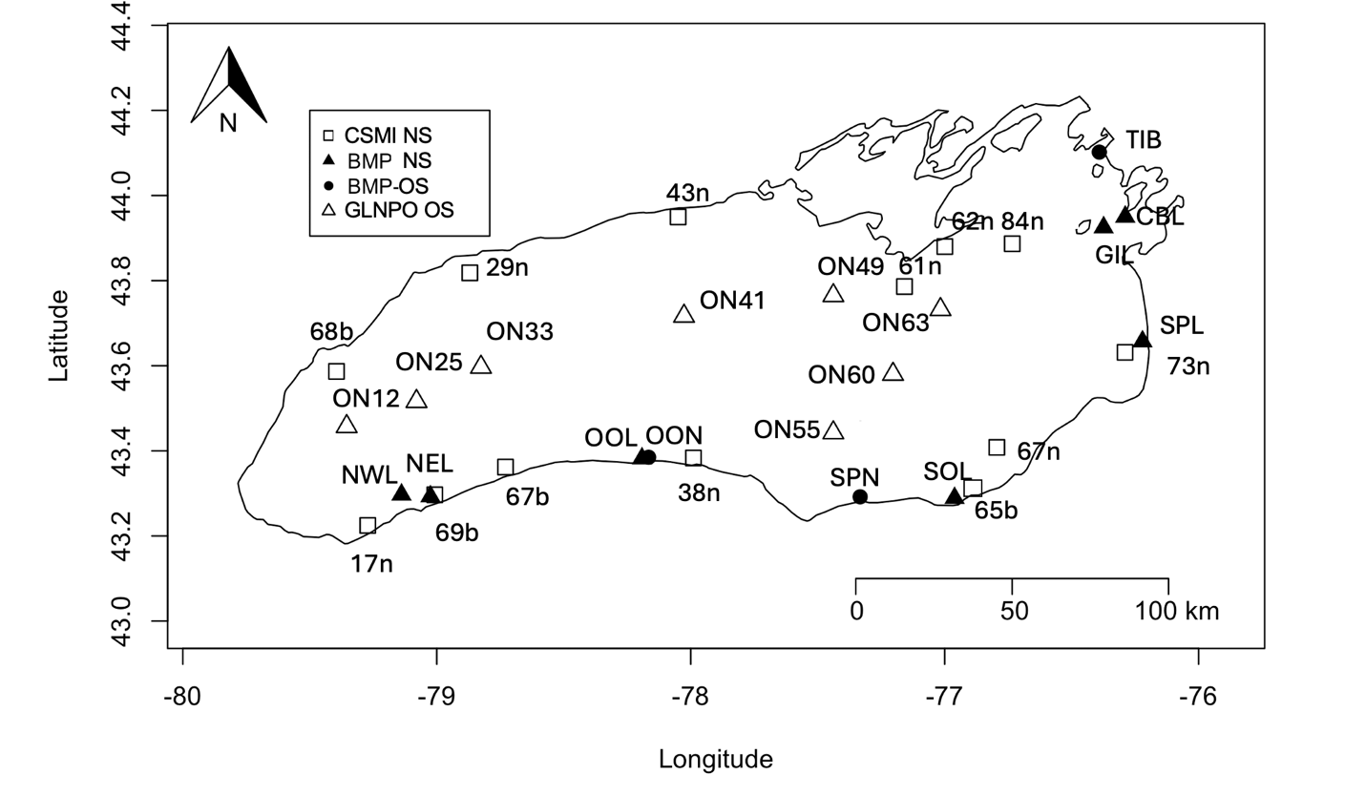
Figure 1. Zooplankton sampling sites in Lake Ontario. The eight LTM offshore sites are identified with open triangles. CSMI nearshore sites are identified with open squares and include 6 sites on the north shore and seven on the south shore. BMP nearshore sites are identified by black triangles. Data from three of the seven BMP deep sites (black circles) are also included here.

The thirteen CSMI nearshore sites (Figure 1) were spaced evenly around the shore of Lake Ontario, and at times align with existing BMP monitoring sites on the south shore. The eight LTM offshore sites (white triangles) are spaced along the central axis of the lake. Generally, site numbers increase from west to east following previously-established sites for the Lake Ontario Lower Food Web Assessment (LOLA), but note that CSMI sites from LTM benthic sampling (ON 65b-69b) do not follow that pattern.
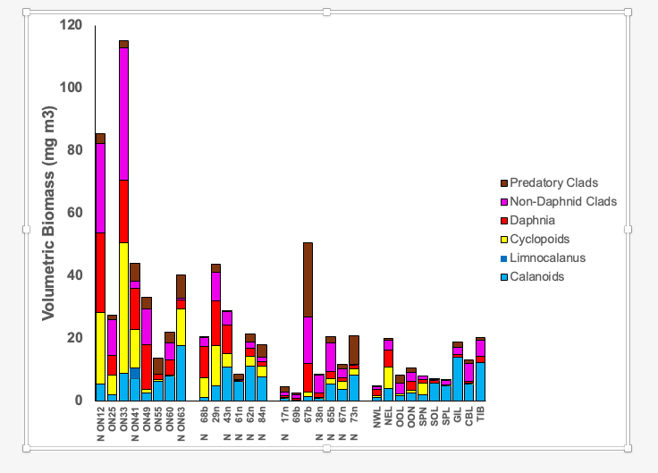

Figure 2. Zooplankton biomass (mg dry wt per m³) for shallow tows at the eight offshore LTM sites, six CSMI nearshore sites along the north shore, seven CSMI nearshore sites along the south shore, and ten BMP sites along the south shore. Sites sampled at night are denoted by N and within each grouping are presented from west to east. Taxa groups are identified in legend by color.

Relative to offshore whole water column tows, nearshore and shallow tows at offshore sites are notably absent of Limnocalanus macrurus, the large deepwater calanoid copepod (Watkins et al. 2017, Figary et al. 2023). Offshore site ON41 was the only site with L. macrurus (dark blue) collected in 20 m tows, in contrast with whole water column tows at offshore sites where the species represented 26% of overall biomass. ON41 was sampled at night when L. macrurus migrates upward. Other crustacean species were consistent between nearshore and offshore samples. Calanoids (light blue) were represented by smaller shallow dwelling species including Leptodiaptomus minutus, Skistodiaptomus oregonensis, and Epischura lacustris. In the upper twenty meters of the water column, zooplankton areal biomass (mg dry wt per m³) offshore (eight sites) was generally higher than the three sets of nearshore sites, but this difference was not significant (Figure 2). The lowest zooplankton biomass observed was recorded at two nearshore sites where the Niagara River enters Lake Ontario (17N and 69b), suggesting a dilution effect from river flow. Copepod composition shifted from west to east for both offshore and nearshore sites, with cyclopoid copepods (yellow, primarily Diacyclops thomasi) prominent in the west and calanoid copepods (blue) prominent in the east. Daphnia species (red, primarily D. retrocurva and D. galeata mendotae) and other herbivorous cladocerans (pink, primarily bosminids and Holopedium gibberum), were generally more abundant in the west. Calanoids have been proposed as an indicator of lower productivity (oligotrophy) while herbivorous cladocerans have been proposed as an indicator of higher productivity (Figary et al. 2024). The pattern of these two indicators follows the general eastward deepening in the slope of the thermocline of Lake Ontario that contributes to an eastward warming of the surface mixed layer and decline in primary productivity. In mid-August 2023 Seabird profiles track the eastward deepening of the thermocline from 10 m depth in the west to up to 25 m depth in the east (Figure 3). Note that considering this pattern, the 20 m tows would include the thermocline in the west, but only the upper mixed layer at eastern sites. For exotic predatory cladocerans (brown in Figure 2), Cercopagis pengoi was more abundant in western Lake Ontario while Bythotrephes longimanus was more abundant in the east, reaching particularly high biomass levels (10-20% of total) for offshore LTM stations ON55M and ON63. Native predatory cladocerans Leptodora kindtii were collected throughout the lake (particularly abundant at ON63 and ON 73n near Sandy Pond, NY) while Polyphemus pediculus was primarily detected in the west (with a strong peak at ON 67b near Olcott, NY.
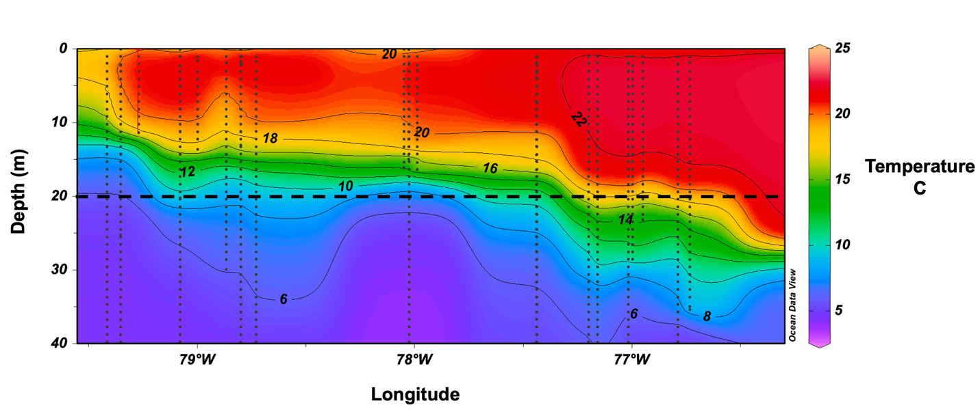
Figure 3. West to east section of Seabird water column profiles of water temperature in Lake Ontario from August 14-16, 2023. Vertical lines represent LTM and CSMI sites. Line at 20 m depth denotes depth of shallow plankton tows.
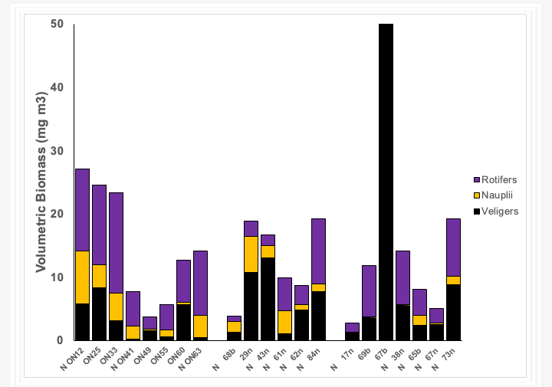
Figure 4. Microzooplankton (veligers, copepod nauplii, and rotifers) biomass for offshore LTM sites and the northern and southern CSMI nearshore sites. BMP data do not have microzooplankton data so are not included. Sites within each grouping are presented from west to east.
Microzooplankton were counted for the GLNPO LTM offshore and CSMI nearshore sites but not the BMP sites (Figure 4). Veligers (black) were a very common component (avg 20%) of nearshore zooplankton biomass and particularly high (66%) for the nearshore site ON 67b on the south shore near Olcott, NY. Rotifers were a large component for both nearshore and shallow offshore samples, overall representing 20% of total biomass. Marshall et al. (2024) tracked seasonal dynamics of rotifers in the previous 2018 CSMI year and observed the peak abundance of rotifers in August. Copepod nauplii represented about 5% of the biomass for both nearshore and top 20 m offshore samples.

Management Connections
The addition of nearshore zooplankton data to existing offshore monitoring expands our understanding of this crucial habitat. Zooplankton is an important food for planktivorous forage fish such alewife and is important for evaluating the capacity of the lake to support forage fish stocks, which in turn impact management decisions such as stocking of salmonids. Nearshore zooplankton are particularly important because the nearshore zones serve as nursery areas for both alewife (Klumb et al. 2003) and coregonids (Brown et al. 2023). Zooplankton is also an important index of the status of the general ecosystem. In addition, taxa specific changes occurred on average three years earlier in the nearshore than the offshore (Figary et al. 2023) making the nearshore zooplankton a leading indicator of coming changes in the offshore. Adding nearshore zooplankton monitoring expands our efforts to detect potential new invaders and monitor previous introductions.

Acknowledgements

We acknowledge the crew and scientists of the R/V Lake Guardian and the NY DEC Biomonitoring Program who collected these samples and the technicians at Cornell who analyzed the samples. Funding was provided by a grant from the U.S. EPA’s Great Lakes National Program Office (GLNPO), Cooperative Agreement GL 00E03089 to Cornell University, with additional funding from NY Department of Environmental Conservation (Contract #140168 to Cornell University). The views expressed in this publication are those of the authors and do not necessarily represent the views or policies of the EPA. Any use of trade, product or firm names is for descriptive purposes only and does not imply endorsement by the EPA.

Literature Cited

Barbiero, R.P., Rudstam, L.G., Watkins, J.M. and Lesht, B. 2019. A cross-lake comparison of crustacean zooplankton communities in the Great Lakes 1997-2016. J. Great Lakes Res 45:672-690.
Bowen, K.L., Currie, W.J., Niblock, H., Ward, C.L., Metcalfe, B., Cuddington, K.M.D., Johnson, T.B., Koops, M.A., 2022. Importance of long-term intensive monitoring programs for understanding multiple drivers influencing Lake Ontario zooplankton communities. J. Great Lakes Res. 48, 717-733.
Brown, T.A., Rudstam, L.G., Holden, J.P., Weidel, B.C., Ackiss, A.S., Ropp, A.J., Chalupnicki, M.A., McKenna Jr., J.E., Sethi, S.A., 2023. Larval cisco and lake whitefish exhibit high distributional overlap within nursery habitats. Ecology of Freshwater Fish 32, 804-823.
Figary, S.E., Holeck, K.T., Hotaling, C.W., Watkins, J.M., Lantry, J.R., Connerton, M.J., Prindle, S.E., Biesinger, Z.F., O’Malley, B.P., Rudstam, L.G. 2023. Lake Ontario’s nearshore zooplankton: Community composition changes and comparisons to the offshore. J. Great Lakes Res. 49:698-712.
Figary, S.E., Watkins, J.M., Lauber, B., Scofield, A.E., Rudstam, L.G. 2024. Revisiting zooplankton as indicators in the Great Lakes: Which indicators detect temporal changes in the zooplankton community composition? J Great Lakes Res. 50:102417.
Holeck, K.T., Rudstam, LG., Hotaling, C., Prindle, S., Pearsall, W., Lantry, J. Connerton, M., Legard, C., Gorsky, D. Farrell, C., Lantry, B., Weidel, B., O’Malley, B. 2025. 2023 Status of the Lake Ontario Lower Trophic Levels. NYDEC Lake Ontario Annual Report 2024.
Klumb, R.A., Rudstam, L.G., Mills, E.L., Schneider, C.P., Sawyko, P.M. 2003. Importance of Lake Ontario embayments and nearshore habitats as nurseries for larval fishes with emphasis on Alewife (Alosa pseudoharengus). J. Great Lakes Res. 29:181-198.
Marshall, C.C., Watkins, J.M., Connolly, J.K., Boynton, P.B., Schaefer, S.L., Currie, W.J.S., Rudstam, L.G. 2024. Patterns and drivers of seasonal succession and vertical distribution in the rotifer community of Lake Ontario in 2018. J. Great Lakes Res. 50:102283
Rudstam, L. G., Holeck, K.T., Bowen, K.L., Watkins, J.M., Weidel, B.C., Luckey, F.C., 2015. Lake Ontario zooplankton in 2003 and 2008: community changes and vertical redistribution. Aquatic Ecosystem Health and Management. 18:43-62.
US Environmental Protection Agency, SOP LG402A, V. 15 2020. Standard operating procedure for zooplankton sample collection and preservation.
US Environmental Protection Agency, SOP LG403, V. 8. 2017. Standard operating procedure for zooplankton analysis.
Watkins, J.M., Collingsworth, P.D., Saavedra, N.E., O’Malley, B.P., Rudstam, L.G., 2017. Fine-scale zooplankton diel vertical migration revealed by traditional net sampling and a Laser Optical Plankton Counter (LOPC) in Lake Ontario. J. Great Lakes Res. 43:804-812.

